IT304 Final Project

J**oshua Threatt**

**Digital Voice Assistant (Siri, Google home)**

1. **Introduction of technology**

In the realm of technological innovation, digital voice assistants have emerged as powerful tools reshaping our daily lives. Spearheading this technological wave are prominent entities like Siri, Google Home.

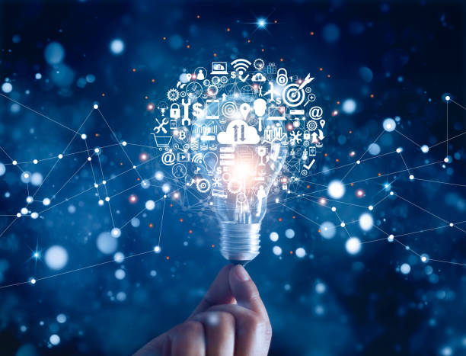

As we delve into the intricate fabric of this transformative force, guided by the insights of Joshua Threatt, our exploration unveils the profound impact and diverse applications of these digital companions. From the widely recognized Siri to the smart home integration of Google Home these virtual companions have become ubiquitous, simplifying tasks and introducing new possibilities. This project delves into the multifaceted landscape of digital voice assistants, exploring their applications, societal impact, and ethical considerations.

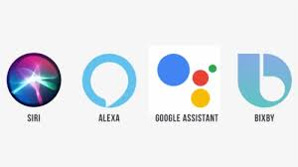

1. **Applications of technology**

In recent years technology has made many advances, one of those advances is the development of Virtual assistants. Many people use virtual assistants to make their day-to-day tasks easier. Virtual assistants are very useful and have many benefits including using your voice commands to carry out actions (commands such as set an alarm, send a text message, set a reminder, read information from websites). Virtual assistants being able to complete tasks like this are efficient and promote multi-tasking, it’s much easier to just shout out a command and get the task you need completed, or information you need relayed to you than it is to take the time and manually do it yourself. One action that amazon’s virtual assistant can complete that most virtual assistants cannot is order products off amazon. Overall, virtual assistants are a great addition to our lives.

Another application of virtual assistants is that they can complete complex things such as locking your doors, turning on/off lights, and changing the temperature on the thermostat. This is specific to amazons Alexa, but virtual assistants can now aid in the medical field, they can detect illnesses such as colds through user’s voice, help manage blood pressure, and diabetes, instruction on first aid techniques. A lot of these medical features relating to the medical field are very useful, in an emergency you could be clueless, but with a simple command your virtual assistant could tell you everything you need to know. The same concepts apply to dealing with diseases/illnesses, for example if a person with diabetes has high blood sugar asks the virtual assistant what to do the virtual assistant will tell them the steps, they need to take to get their blood sugar back down. These are only a few of the many things that virtual assistants can accomplish.

Just like with most technology there are social challenges with virtual assistants. A lot of people don’t trust virtual assistants because they actively listen to your conversations and even at times record them. There is one example of Alexa recording an alleged murder suspect, in this case the recording let the authorities know what happened, but many people weren’t happy to know this because they aren’t happy with companies having accesses to their personal conversations. It makes it difficult to implement these types of devices in your home since you will be compromising your privacy.

<https://www.digitalauthority.me/resources/alexa-in-healthcare/>

<https://www.nbcnews.com/news/us-news/amazon-s-alexa-may-have-witnessed-alleged-florida-murder-authorities-n1075621>

1. Critical Discussion of technology

* With the recent introduction of powerful new A.I. such as CHAT-GPT and the continued advancement of voice recognition technology, virtual assistants b could soon enter the realm of what was once sci-fi. Like the cars in the early 20th century an ever-growing number of people could soon have a customizable virtual assistant that can answer all your questions. With something so human like the effects on the loneliness epidemic could be greatly exacerbated. Such technology can have a significant impact on politics. If it is actively connected to the internet or the model has significant bias, we could see people's opinions and political preferences change if people use the technology heavily. **(1)**
* If we are to look at the technology from different ethical lenses it needs to be examined as applied to different aspects of life. If applied to education one can think of a tool humans have real time dialog within order to help them learn the subject matter and complete the assignment. We can also imagine an improper use wherein students only learn how to interact with the assistant as far as getting it too correctly think through problems. This is without learning any of the material themselves. On the one hand, we can have humans that are super learners able to bootstrap arbitrarily complex information and put it to use. On the other hand, we have humans who are masters of getting the technology to accomplish tasks only knowing the minimum necessary amount of information. The former could have a beneficial impact when it comes to human creativity, engineering, learning, etc. The latter could be very dangerous as we may know none of the implications of the actions we take. The most likely outcome is we have some ratio of both. God help is in so that former be as large of a piece as possible. **(2)**
* The path forward is narrow so how we proceed is of the upmost importance. I would say we’re walking across a type of rope but that would be underselling the difficulty of what we’re undertaking. On one hand if we do absolutely nothing regarding policy and recommendations, we run the risk of a cancerous form of the technology becoming the dominant form. However, if we put so many rules in place that we significantly raise the cost of development past the point of the small or medium sized company we risk a possibly equally as bad outcome. The technology could end up never being developed harming future economic growth, or we could end up unintentionally creating a regulated monopoly. To help solve this problem I would recommend creating a comprehensive citizen board as was done in California in 1967. This citizen board would be advised by a large group of scientists from various schools. People from not only A.I./voice recognition fields but also economic, agricultural, developmental biology, math and many more. This initiative would be nationwide and last 3-5 years. A version of this plan that works on a state-by-state basis should also be considered and may even be favorable as it would better take into account local conditions. If any rules are to be applied to the field, I think they should overwhelmingly be general rules that set standards rather than force specific development paths. This is because we don’t want to automatically rule out any presently unknown but beneficial developments. **(3)**